Analyzing Blue Apron Meal Kit Service: A Consumer Behavior Perspective
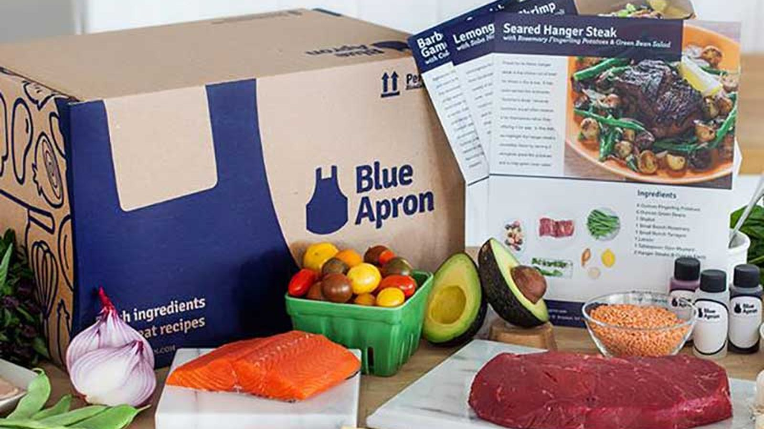

Mahima Dutt
MKT 450: Consumer Behavior
Fall 2017

Table of Contents

Introduction to the Service 3-4

Section 1: Target Audience: Demographics and Psychographics 5

Section 2: Marketing strategy 6-8

Section 3: Motivation, Ability, and Opportunity 8-10

Section 4: Values-driven mission and brand positioning 11

Section 5: Competitors and Current Market 12-13

Recommendations for improvement 14-15

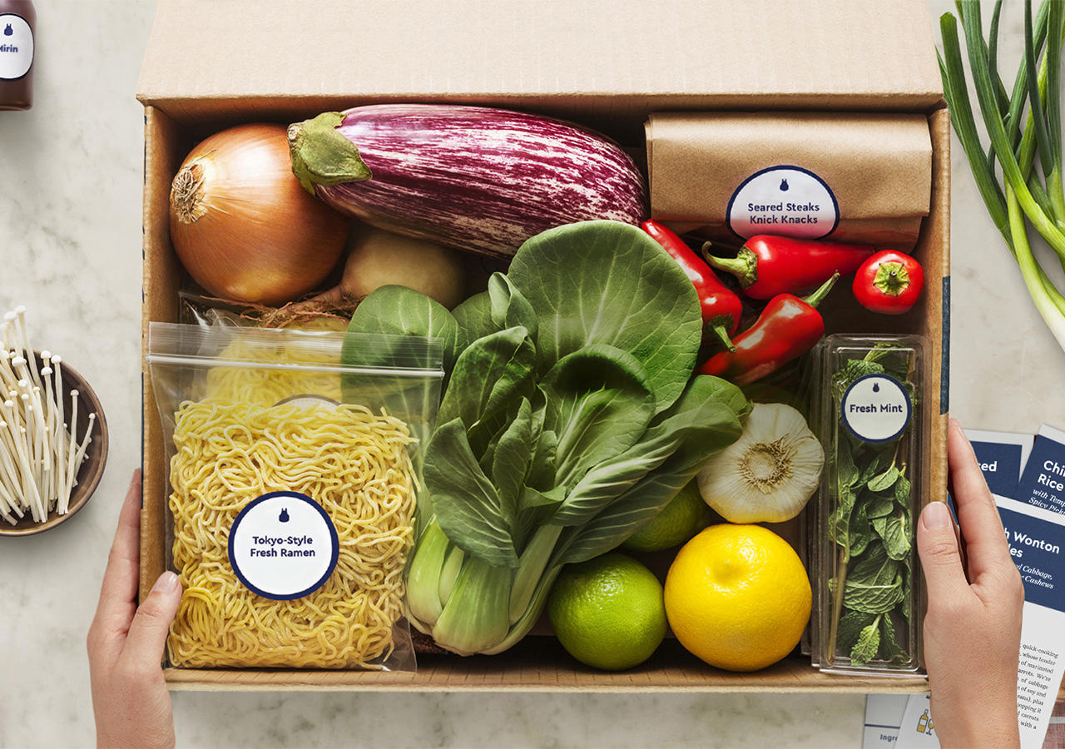
Blue Apron is a meal-kit service that is aiming to take on our current food system by cutting out the middleman when buying ingredients for home-cooked meals. Their motto “because food is better when you start from scratch” encompasses the main premise it’s trying to sell, which is to encourage people to cook using fresh ingredients and recipes that are conveniently provided by Blue Apron. It is selling more than just a product, but rather an experience of cooking at home. The company was founded in 2012 and refers to its customers as ‘home chefs’. Currently, it has a subscription business model where consumers can select a two person or family plan (serves four) as well as the number of recipes they want delivered straight to the consumer’s door. The subscription can also be canceled at any time. An example of their meal kit is shown below.

An interesting aspect of their company is the name. It was chosen deliberately because of its symbolic meaning. According to their website, the name was selected because apprentice chefs wear blue aprons when learning to cook and “for [Blue Apron] it has become a symbol of lifelong learning and a reminder to approach every situation with humility and curiosity” (Our Values).
The company operates on the basis of four main tenets. First, it is aiming to create a better standard for food by ensuring that all ingredients are farm fresh and high quality. It is also environmentally conscious and is concerned about farmland use. For this reason, its’ second goal includes regenerating the land that their farmers use in order to keep it healthy and give back to make up for what is being stripped from the land. Another key component of their business model is the fact that it is eliminating the middleman, which includes grocery stores primarily. Lastly, the company is prioritizing reducing food waste, which is also central to their business as it only packages and delivers specific quantities of food that the consumer orders.
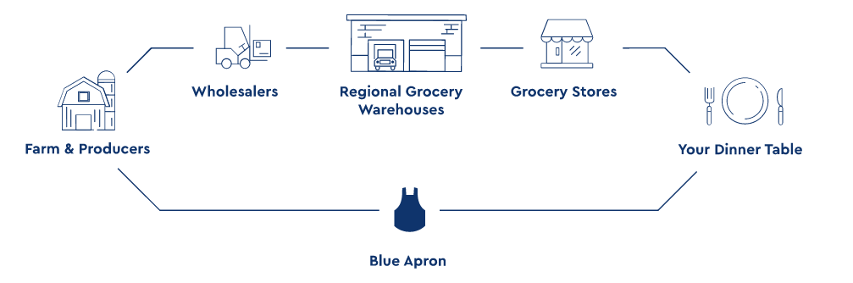
Their business model is illustrated above. This model is a visual demonstration of how the company is able to achieve the aforementioned tenets. For instance, the company can guarantee high-quality ingredients since their food is delivered directly from farms and producers, so it is not going through the entire process of being delivered from a wholesaler to a warehouse to a grocery store, where it could end up sitting on a shelf for days. The company has also partnered with over 150 farms in order to collaborate and maintain the farmland through regenerative agriculture or the idea of “putting more back into the land than you take” (Our Vision). One of the ways it accomplishes this is by customizing their menus according to crop cycles and also limiting the use of pesticides and fertilizers.

Target Audience: Demographics and Psychographics
Since its launch, Blue Apron’s target market expanded from young working professionals to young families too. The idea behind its subscription plans reflects this target audience as young millennials living together could potentially subscribe to the two person meal plan and young families could order the family plan. In June of this year, TechCrunch reported that consumers between the ages of 25 and 44 years old comprise over half of the company’s business (Lynley). Additionally, the company only has three fulfillment centers currently and since their meal kits include perishable food, it is also logical to target metropolitan cities with denser populations. People living in these metropolitan cities also value convenience and are more open to purchasing online, making them a strong target audience.
The company’s consumers include young, urban millennials, who align with the company wide values of health, authenticity and the environment. The company has benefited from more recent trends prompting people to become more health conscious and strive to be healthier through their diet especially. Forbes also found that “millennials are the generation leading the health food trend and value products that are organic, local and contain fewer preservatives and processed chemicals” (Fromm para. 5).
Additionally, consumers value the authenticity aspect of the company in terms of ensuring fresh ingredients are used and being transparent about how the food is grown authentically and naturally. Lastly, Blue Apron’s consumers are environmentally friendly and socially conscious, as they want to support social initiatives that benefit the environment as well. There can also be a case made for strong home and family values, as the Blue Apron brand is very wholesome and community-oriented. It encourages people, especially families to cook together as well as enjoy and share the meals together.

Marketing strategy
Blue Apron was very successful in its first two years after launch through their well-executed marketing strategy that involved word of mouth marketing (WOM), consistent social media presence and effective advertising that helped them grow their subscriber base. In fact, in 2015 alone, the company grew by 500 percent, delivering 5 million meals to subscribers per month (St. Louis para. 3). This growth can arguably be attributed to the company’s online advertising and marketing efforts. Blue Apron encourages its home chefs to share their experience of using the service with others. Whether it is through taking pictures of one’s home-cooked dish using the Blue Apron meal kit or even recommending it to friends and family through the customer referral program, word of mouth advertising helped the company significantly. One subscriber was notably impressed with the service and the packaging that included reminders to share their accomplishment of cooking a meal using Blue Apron. For instance, the meal kits include “handy recipe cards, complete with images, time-saving tips, and more. It even has social calls to action throughout the recipe card, encouraging the home chef to share their creations with the world—because a meal is not complete until there’s an Instagram post to prove it” (Steiert para.7). Including a reminder to share the experience of Blue Apron within the packaging was a clever way to drive word of mouth marketing.
In addition to WOM, Blue Apron is also known for its social media presence across platforms such as Instagram and Facebook. The brand has successfully cultivated a community and forum style Facebook page where home chefs can share their experiences and tips. Senior director of marketing, Rani Yadav discussed their audience on Facebook in particular in an interview last year with Inc. “Blue Apron has cultivated 1.2 million fans on Facebook who proudly showcase their masterpieces. "The engagement on social is what's most astounding," Rani says. "You can't buy people to comment and talk about your brand with the love and enthusiasm that our community does. And these are people who would never talk to each other in the real world, but on our social-media channels they're sharing tips about cooking bok choy--it's so fun to see” (St. Louis para. 9)!
Not only is social media utilized to elevate word of mouth and user generated content but it also introduces opportunities for partnerships. In the past, Blue Apron partnered with several YouTubers such as Kandee Johnson as well as YouTuber and fitness blogger, Hungry Runner Girl according to influencer marketing agency, MediaKix. Blue Apron was able to choose influencers who aligned well with the brand and its values. These partnerships also were successful in creatively integrating Blue Apron’s messaging into influencers’ highly trafficked social channels. For example, Hungry Runner Girl reaches a more health-focused audience that is likely to be more susceptible to Blue Apron’s advertising (MediaKix para. 1). Additionally, influencers are trusted among their followers and their use of the meal kit service further validates Blue Apron as a legitimate business or experience, increasing brand awareness. Furthermore, there is a multitude of Youtube videos where people review Blue Apron and their experience, creating more brand awareness and recognition. Since Blue Apron is a food service business and its main product is the meal kits or the food it provides subscribers, it is able to capitalize on the aesthetics of food especially on platforms such as Instagram, where the company has nearly 300K followers. The company was very active on its Youtube channel too as it posted numerous ‘how-to’ cooking videos, in order to become even more accessible to its audience.
Lastly, Blue Apron’s marketing strategy involves mostly online advertising. The company released two advertisements in the beginning of this year outlining its values and mission of creating a better food system that is better for consumers in terms of health and better for the environment. Both advertisements were very values driven, positioning the company as socially responsible. The longer advertisement also featured on its website creatively told the story of how Blue Apron wants to change the food system by asking viewers to imagine a different system. The advertisement especially emphasized the partnership with farms and the importance of caring and maintaining the land. This appeals to consumers who care about where their food comes from as well as environmentally conscious consumers.

Motivation, Ability, and Opportunity
Blue Apron is able to effectively motivate consumers to try its product through characterizing its service as a novel experience that is low risk. The no commitment policy allows subscribers to cancel the service whenever they want. This minimizes the perception of risk involved, encouraging more people to try the service without any penalty or long-term commitment. Moreover, the company brands its service as an experience. Ordering a Blue Apron meal kit isn’t simply about ordering fresh ingredients but its also largely about cooking a home-cooked meal and really transforming into the role of ‘home chef’. Since the idea is so innovative and different than traditional means of cooking or shopping, people may be motivated to try it out for that reason. If they are also seeking variety, Blue Apron is a good option as the meal kits often include unique recipes and foods that people may not necessarily use in their regular cooking.
The meal kit service also fulfills several types of needs, motivating consumers further to purchase such a product. Food is a physical need so clearly eating a healthy home-cooked meal serves a functional purpose in satisfying hunger, maintaining energy and overall good health. Home-cooked meals also satisfy more than just hunger but also fulfill a hedonic need as the meals itself taste delicious and boost a person’s overall mood. Lastly, the idea of cooking a meal at home with fresh ingredients and unique recipes designed by real chefs certainly gives consumers a sense of accomplishment and pride, relating to a symbolic need or sense of self.
Although the premise of the company might intimidate consumers who are not necessarily skilled in the kitchen, Blue Apron excellently equips its consumers with the ability and knowledge to truly feel like a chef. The product does not discriminate against people who are not experienced cooks. In fact, Blue Apron provides abundant resources in order to ensure that the experience of using the meal kit is smooth and easy, rather than stressful. Its resources include the recipe cards that are delivered with the meal kits. These recipes are also available online for free, cultivating brand trust and encouraging people to cook at home more. Blue Apron’s Youtube channel is another easily accessible resource with a large collection of how-to videos. Overall, the company does a great job of educating its customers and filling in the educational gap from its packaging to its recipe cards. In addition, their social media platforms serve as a forum for consumers to interact with each other and offer tips. Consumers can also be any age since families can cook together and children can be involved in the cooking process. The meal kit service is also relatively affordable, making it a viable option for not only working professionals but other groups too that may not have enough time to buy fresh groceries. Out of its competitors, Blue Apron remains one of the most affordable meal kit providers. This is exemplified through its pricing strategy. The two-person plan with three recipes a week is only $10 with free shipping, which is extremely reasonable and cost saving in the long run. The user-friendly resources and affordability bolster the consumer’s ability to purchase such a product.
Similar to the company’s efforts to increase motivation and ability, Blue Apron also provides its consumers with opportunity in the form of time, easy to understand resources, and the experience of trying something new. The meal kit service can save consumers a considerable amount of time since they won’t need to go grocery shopping or even worry about what to make for dinner. Blue Apron is able to deliver fresh ingredients right to their home and include recipes that can be adapted to fit dietary restrictions or other needs. The product is not only convenient, but also beneficial to consumers’ overall happiness and stress level due to the extra time they are able to save. Although the actual act of cooking the food may take more time than a person regularly spends on dinner, it is treated as an experience and it is justified because of the quality of the ingredients and the meal overall. Second, the ease of using this service is only possible because of the accessible resources that Blue Apron provides. The company makes a strong effort to include simple instructions in their recipes and cater their product to varying levels of cooking experience. However, the biggest opportunity presented by the product is the experience of trying something new whether it’s cooking a new recipe or actually eating a meal you've never had with ingredients you may not be familiar with either or ingredients that are cooked in an unexpected way.
Values-driven mission and brand positioning
Through its advertising, Blue Apron positions its brand as a solution to the current food system using problem recognition. Through its messaging, the company consistently defines in it's the current food system as a problem. As a result, Blue Apron can position itself as the solution or way to fix the problem, emphasizing its promotion focused mission. It is able to create dissatisfaction with the actual state and prompt consumers to imagine a better food system through its online advertisements primarily. This is a successful technique to persuade consumers to strongly consider the brand when deciding whether to buy. Blue Apron’s marketing challenge is partly becoming part of that consideration set in the first place since the nature of its product is new to many people and this strategy of problem recognition is an effective way to be included in consumers’ consideration sets.
The brand itself outlines five key values on its website that the company holds in high regard including lifelong learning, trust, quality, teamwork and empowerment. Its values are not only abstractly discussed but also concretely demonstrated through various initiatives the company has taken. First, the lifelong learning is reflected in the name ‘Blue Apron’ and its employees, who are trying to constantly learn from each other and learn more. Next, Blue Apron knows that its service relies heavily on trust and consumers trusting it to help put a healthy meal on the table. The value of quality is seen through the freshness of ingredients and attention to detail in the overall meal kits, such as including recipe cards. The teamwork is evident not only in the organization itself but also underscored through the family meal plan option, that can encourage families to cook together. Lastly, empowerment is an interesting value that might not be immediately associated with the company. However, the company is trying to establish itself as again a solution and way for consumers to make a socially good decision. It suggests that the meal kit service empowers people to form a better food system, reduce food waste, and treat the environment better. These values are not only standards for the company but goals as well in terms of increasing their brand trust, food quality, teamwork and empowerment efforts.
Competitors and Current Market
The meal kit service market has several competitors, all with similar business models. The next largest company next to Blue Apron is Germany-based startup HelloFresh. Plated, Sun Basket and Home Chef are other smaller competitors in the market. Additionally, Amazon’s partnership with Whole Foods has affected Blue Apron’s stock price as Amazon is a large player and its partnership with a grocery store could help increase accessibility and reach to consumers for their services. All companies are similar in their model of delivering meal kits to consumers with the goal of eliminating food waste. Blue Apron, however, has a longer, more compelling values-driven mission with their four main tenets. In terms of marketing, all services emphasize the ease of cooking and use of the product. They all maintain having fresh ingredients as well as enjoying the fun experience of cooking in the kitchen. They also all appeal to health conscious consumers that are looking to save time. Because all companies position their product similarly, they are all competing for a similar target audience and are often compared closely with each other. Consumers will write and post reviews online and on Youtube comparing Blue Apron to other meal kit services. This also affects retention rate. According to Recode, “a year after first purchase, Blue Apron held on to 15 percent of its customers”, which is better than its competitor HelloFresh yet some of the smaller companies in the market have higher retention rates, again showing that people are not necessarily brand loyal yet or consistent in their purchase behavior and instead are trying different options and comparing. Currently, Blue Apron is still the dominant player in the market with 40% of the market share, as of November 2017 as shown in the graphic below (Molla para. 3).
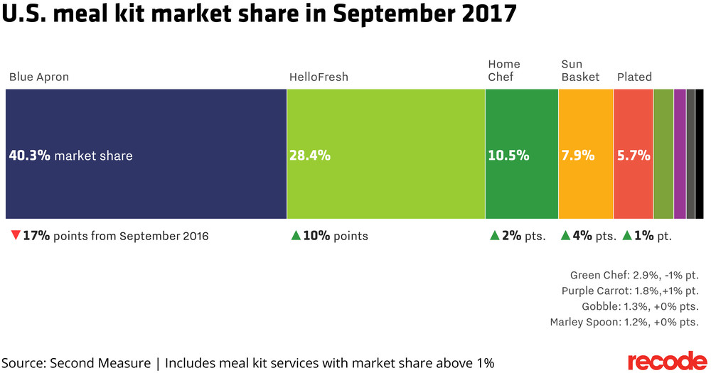
The current market shows Blue Apron is not performing well like it was in its first two years. The company is facing several serious challenges related to production and costs. As they looked towards scaling and expanding, they did not estimate the high costs of their fulfillment centers, leading to warehousing issues (Skrovan). The prospect of Amazon joining the market also negatively affected their stock. Unfortunately, since their IPO in June, the company has been losing money consistently as well as losing consumers and has been in the news for having one of the worst IPOs this year (Skrovan). They are not able to spend as much on marketing, which means they are not reaching new consumers as much, decreasing their overall revenue. This unfortunately perpetuates a vicious cycle as their limited funds for marketing affect their monetary intake, which affects their budget in turn. Other challenges that they are facing include scaling and expanding nationwide. They also currently reach a young demographic that mostly lives in metropolitan cities and reaching a wider audience has been a challenge, especially with scaling problems. Lastly, retention as mentioned before, is another aspect that the company needs to work on in order to maintain a consistent revenue stream.
Recommendations for improvement
I partly chose Blue Apron after seeing it in the news a lot because of its financial troubles. I saw an opportunity to analyze the company’s audience and market and make useful recommendations for their marketing strategy in order to hopefully reverse the current effects. My recommendations are made in consideration of the limited funds and market position the company is currently in. First, I believe Blue Apron can capitalize more on user-generated content, since it is less expensive than creating their own promotional material and it can boost engagement and brand trust. For instance, Blue Apron can take tips from social media savvy companies like Glossier in reposting its consumers’ content on Instagram. Reducing overhead costs is still highly important but in terms of how to allocate the funding, I believe advertising on at least one social media platform is still necessary as it is the most effective way to reach its target audience including new consumers especially.
Finally, I believe Blue Apron has untapped potential in certain markets. The company can do more to reach an older demographic as well as people living in more rural areas, who may have limited options for food and fresh ingredients. There is a strong case for expanding their target audience to the older generations as “baby boomers spend far more, and they could increasingly see the merits of grocery delivery as they age” (Bary para. 1). Blue Apron could also advertise itself to “affluent retirees” who would enjoy a high quality home-cooked meal (Bary para. 3). In terms of reaching this new market segment, the company would have to do market research into how their product could fit into current consumer behavior and lifestyles of an older demographic. Additionally, it would be smart to advertise to these populations by featuring them more prominently in their social media campaigns or online video advertisements in order to add to its social value and normalize it. In order to effectively reach this demographic, it would also need to pursue more traditional forms of advertising that are offline. Expanding to an older market can significantly help the company in terms of maintaining a more brand loyal subscription base that consistently spends since older people may use the service continually if it is hard for them to physically go to the grocery store. Similarly, stronger messaging toward college-aged consumers could benefit the company in the short term. Although this demographic may not be as brand loyal, they are health conscious and value convenience and this product can fulfill a gap or need in their lifestyles.
Despite the financial challenges and problems with scaling, Blue Apron still provides an interesting case study because of its immense growth in its first two years as well as its strong content marketing strategy. The brand highlights its mission and values so strongly that it is very much ingrained in the brand image and persona. It’s a family-friendly, accessible brand that is seen as socially conscious and authentic. Blue Apron is not only a pioneer in its market for being one of the first meal kit services to expand nationwide so quickly but also still a disruptor in its industry, consistently working to better our food system, which is an important goal.

Works Cited
Bary, Emily. “Why Blue Apron Needs To Rethink Its Target Audience.” Barron's, Barrons, 25 Sept. 2017, www.barrons.com/articles/blue-apron-stock-upgrade-1506356533.
Fromm, Jeff. “Birchbox, Blue Apron And Bark Box Are Creating Connected Experiences With Millennial Consumers.” Forbes, Forbes Magazine, 12 Oct. 2015, www.forbes.com/sites/jefffromm/2015/01/21/birchbox-blue-apron-and-bark-box-are-creating-connected-experiences-with-millennial-consumers/#7342ae2b7819.
Lynley, Matthew. “Meal Ingredient Delivery Service Blue Apron Is the next Big Consumer IPO.” TechCrunch, TechCrunch, 1 June 2017, techcrunch.com/2017/06/01/meal-ingredient-delivery-service-blue-apron-files-to-go-public/
MediaKix. “Blue Apron Influencer Campaign - Mediakix.” Mediakix, MediaKix, 7 May 2014, mediakix.com/portfolio/blue-apron/#gs.CPYpUjg.
Molla, Rani. “Blue Apron Still Dominates the Market for Meal Delivery Kits but Its Market Share Is Plummeting.” Recode, Recode, 1 Nov. 2017, www.recode.net/2017/11/1/16581142/blue-apron-market-share-decline-meal-kit-delivery-hello-fresh.
“Our Vision.” Blue Apron: Fresh Ingredients, Original Recipes, Delivered to You, www.blueapron.com/pages/vision.
“Our Values.” Blue Apron: Fresh Ingredients, Original Recipes, Delivered to You, www.blueapron.com/pages/our-team.
Skrovan, Sandy. “Blue Apron Stock Plummets to All-Time Low as New Fulfillment Facility Erodes Profits.” Food Dive, 8 Nov. 2017, www.fooddive.com/news/grocery--blue-apron-stock-plummets-to-all-time-low-as-new-fulfillment-facility-erode/510348/.
Steiert, Jon. “Why Your Company Needs to Think More Like Blue Apron.” Convince and Convert: Social Media Consulting and Content Marketing Consulting, Convince & Convert, 3 May 2017, www.convinceandconvert.com/customer-experience/think-more-like-blue-apron/.
St. Louis, Molly. “The Brilliant Marketing Strategy That Helped Blue Apron Find Success.” Inc.com, Inc., 25 Mar. 2016, www.inc.com/molly-reynolds/how-blue-apron-cooked-up-its-delicious-content-marketing-strategy.html.

